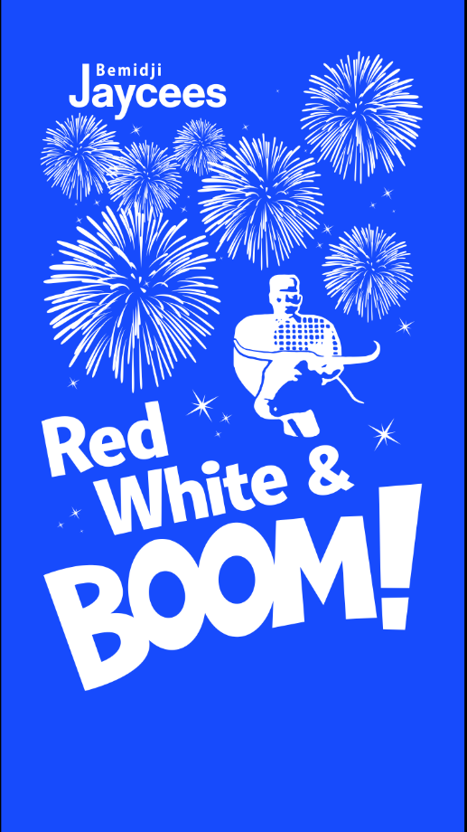
The Bemidji Jaycees are seeking businesses, organizations, and individuals to “Adopt-A-Banner” for the 2015 Water Carnival. The cost per banner is $125; they will be available for renewal at a lower rate for following years. The banners will be on the light poles downtown.

_______Yes, I would like to sponsor ___________ banner(s) at $125 each=______________

Contact:_______________________________________________________________________
Address:_______________________________________________________________________
Phone:_______________________________ E-mail:___________________________________
Business name as printed:_________________________________________________________

Please complete and return this for as soon as possible with your check enclosed to:
Bemidji Jaycees
PO Box 293
Bemidji, MN 56619

